🏫 BITS Pilani – History, Evolution & Present-Day Working


📜 Origins and Early History
The story of Birla Institute of Technology and Science, Pilani (BITS Pilani) begins long before it became a premier engineering institute. Its roots trace back to 1901, when a small school named Pathshala was established in Pilani, Rajasthan by the visionary industrialist family led by Ghanshyam Das Birla. The Birla family strongly believed in education as a tool for national development, especially during India’s pre-independence period.
Over time, this modest institution expanded into a full-fledged college known as Birla Engineering College in 1946. It was among the early institutions in India focusing on technical education, aligning with the country’s growing industrial needs. The college gradually gained recognition for its quality teaching and discipline.
A major transformation occurred in 1964, when the institute was restructured into BITS Pilani. This reorganization was inspired by the academic model of leading global institutions like the Massachusetts Institute of Technology (MIT), emphasizing flexibility, research, and continuous evaluation.

🎓 Academic Innovation and Growth
BITS Pilani introduced several groundbreaking concepts in Indian higher education:
- Continuous Evaluation System: Instead of relying solely on final exams, students are assessed throughout the semester via quizzes, assignments, and tests.
- Dual Degree Programs: Students can pursue two degrees simultaneously (e.g., B.E. + M.Sc.).
- No Reservation Policy: Admissions are purely merit-based through the BITSAT entrance exam.
- Practice School (PS) Program: A unique internship system where students gain industry experience during their studies.
These innovations made BITS stand out among Indian institutions and helped shape modern engineering education in the country.

🌍 Expansion Across India and Beyond
Initially based only in Pilani, BITS expanded to meet growing demand:
- Goa Campus (2004) – Known for its scenic location and strong research culture
- Hyderabad Campus (2008) – A modern campus with advanced infrastructure
- Dubai Campus (2000) – First international campus, catering to global students
Each campus maintains the same academic standards, curriculum, and evaluation methods, ensuring uniform quality across locations.

🧑‍🏫 Academic Structure and Courses
BITS Pilani offers a wide range of programs:
- Undergraduate (UG): B.E., B.Pharm, M.Sc.
- Postgraduate (PG): M.E., MBA (Business Analytics), M.Pharm
- Doctoral Programs (PhD) in multiple disciplines
The institute is known for its flexible academic system, allowing students to choose electives across disciplines. This interdisciplinary approach prepares students for diverse career paths.

🏢 Industry Collaboration & Practice School
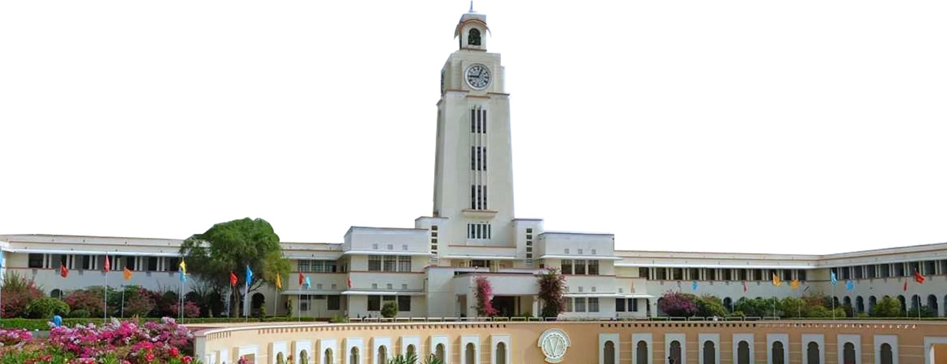
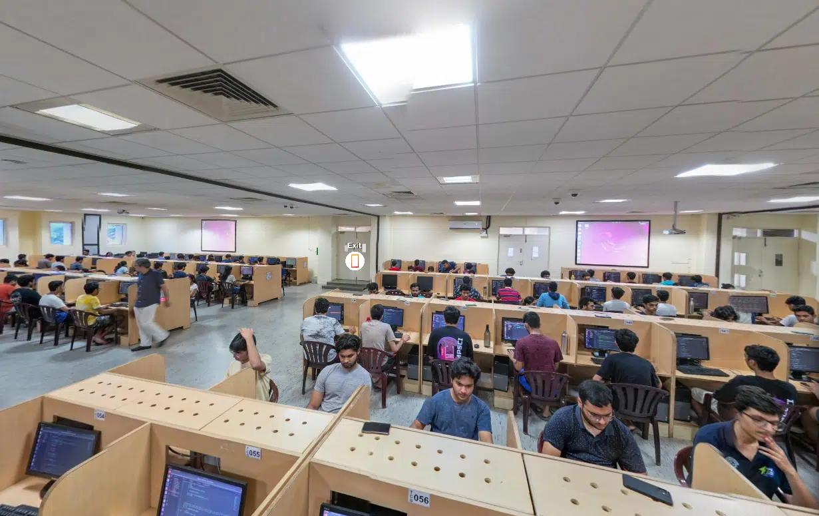
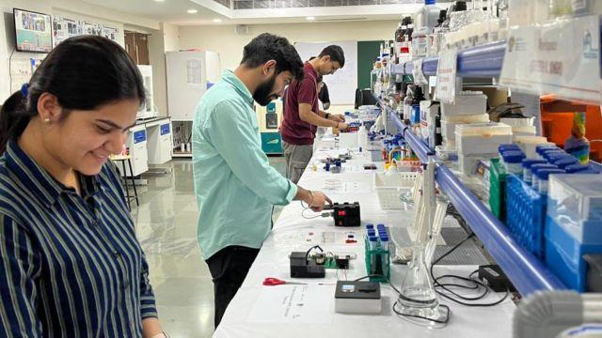
6
One of the most defining features of BITS Pilani is its Practice School (PS) Program:
- PS-I: Short internship after 2nd year
- PS-II: Full semester internship in final year
Students work in top companies, research labs, and startups. This ensures they graduate with real-world experience, making them highly employable.
BITS has strong ties with industries like IT, manufacturing, finance, and consulting. Many companies actively recruit from BITS due to its practical training approach.

💡 Research and Innovation
BITS Pilani has steadily built a strong research ecosystem:
- Advanced labs in engineering, sciences, and biotechnology
- Collaboration with international universities
- Funding from government and private sectors
The institute encourages student-led innovation, startups, and entrepreneurship. Many successful startups in India have founders from BITS Pilani.

🏫 Campus Life and Culture

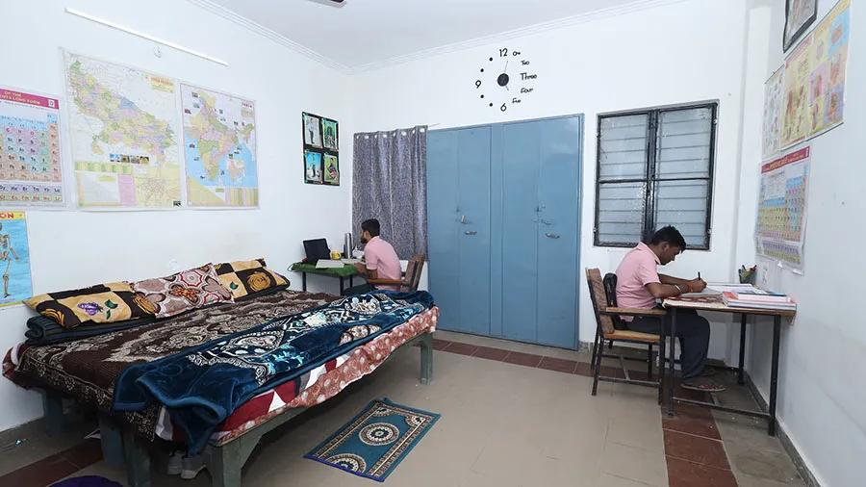
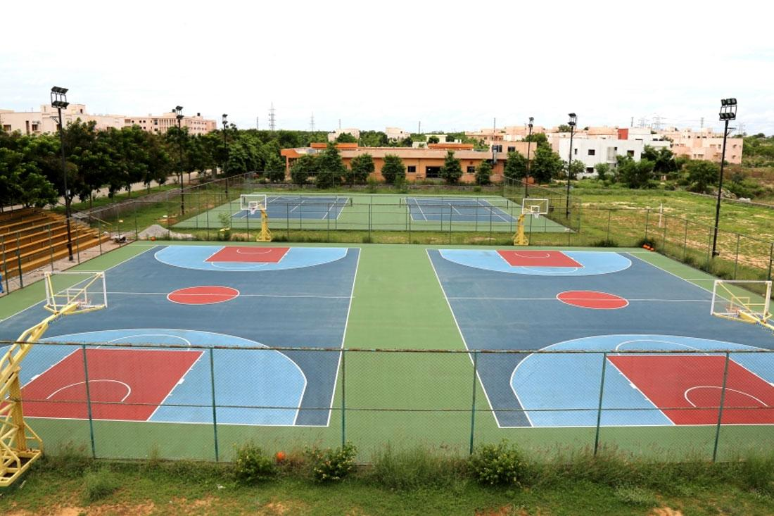
7
BITS Pilani is famous for its vibrant campus life:
- Oasis – Cultural festival
- APOGEE – Technical festival
- BOSM – Sports festival
Students manage most activities independently, which builds leadership and organizational skills. The institute follows a zero-attendance policy in many courses, encouraging self-discipline and responsibility.
Hostel life is an integral part of the experience, promoting collaboration, networking, and lifelong friendships.

🏆 Reputation and Achievements
BITS Pilani is consistently ranked among India’s top private engineering institutions. Its graduates are known for:
- Strong technical knowledge
- Practical industry experience
- Entrepreneurial mindset
Alumni of BITS Pilani hold leadership roles in top global companies, startups, and research organizations.

🚀 BITS Pilani Today (Up to Now – 2026)
Today, BITS Pilani stands as a globally recognized institution with:
- Multiple campuses (Pilani, Goa, Hyderabad, Dubai)
- Thousands of students from across the world
- Strong placement records with top companies
- Growing focus on AI, data science, and emerging technologies
The institute continues to evolve by updating its curriculum, expanding research, and strengthening global collaborations.

🔚 Conclusion
From a small school in 1901 to a world-class university, BITS Pilani has come a long way. Its emphasis on innovation, flexibility, and practical learning sets it apart from traditional institutions. With its strong academic system and industry integration, BITS continues to shape future engineers, scientists, and entrepreneurs, maintaining its legacy as one of India’s most respected educational institutions.

